John Thomas. 1831 – 1917.
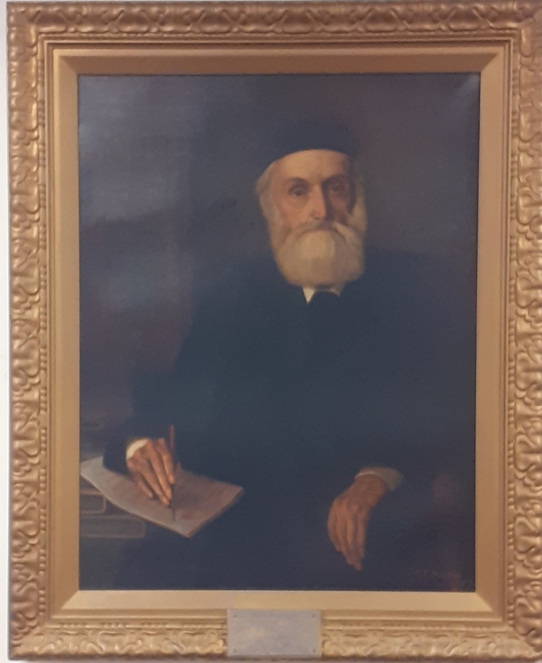

This is a portrait of John Thomas who was clerk to the Brynmawr Urban District Council (UDC) for over 55 years; it was presented to John Thomas as a token of the council’s appreciation of his dedication and work for the town. The portrait was painted by George Frederick Harris who lived in Merthyr before moving to Cardiff (where this portrait was done), later the Harris family emigrated to Australia. George F. Harris was also Rolf Harris’s grandfather. This portrait now hangs in Brynmawr Town Council’s Chambers but quite possibly it is not the original painting. On the occasion of John Thomas’s completion of 55 years' service as clerk to Brynmawr’s UDC, he was warmly congratulated and one of the members intimated that he would be very pleased to contribute towards the cost of a painting of their veteran official that would be presented to him. This was taken up and the councillors and residents of Brynmawr contributed generously towards the project. It shows how much the people respected John Thomas as the amount donated was more than enough to have the portrait painted.
Very early in his career John Thomas was a collier and as a young collier, life for a working person was hard, living was quite expensive with bread for example being very dear and the flour used to make the bread was often of very poor quality. Fresh meat was a luxury and any meat portion was often only bacon. Milk was very rarely used as food, only used in tea. A person would seldom have what could be termed “best clothes” and working men would use oil to clean their working boots for Chapel on a Sunday. . A collier had to work hard to earn £1 a week and to get the highest wage you needed to be on good terms with the weigher. How you were paid was also different to today, men working at Nant y Glo were paid by the “batch” (each batch, or group of workers, would have one of the better educated members as their leader). Payment would be given to a member of the “batch” by means of notes on Crawshay Bailey’s Bank as well as a little change. The landlord of the local inn would be trusted to change the notes for a little consideration of 2/6 (25p in today’s money) for each £5 note. The wage would then be shared between the members of the batch. This is well after truck money and the dreaded company shop. The truck system had been made illegal in 1830 though some unscrupulous owners still used it for many years after.
At the age of twenty years John Thomas entered the Normal College in Swansea. Following his time at Swansea he was, early in his council career, a clerk and surveyor and then finally a clerk exclusively for the Brynmawr Urban District Council though he was referred to in one newspaper as “John Thomas rent collector and brick merchant”.
John Thomas lived through quite an important period in local history and he saw, and probably made some startling changes. His early life in Brynmawr was to set him up for his future career.
His mother believed strongly in education for her children and John and his sister were sent to a “Dame School” situated on the corner of Somerset Street and Worcester Street. The teacher was a man who had fought in the Napoleonic War. One day on their way to school passing the grass embankment on Alma Street they saw that women that morning had been washing their bed sheets and had lain then on the grass bank to dry. John and his sister laughing decided to run over the sheets in their muddy boots. They then ran to school. They had not been there long before two very irate women carrying the mud stained sheets, came into the school and told the teacher what John and his sister had done. The teacher said he would deal with the two naughty children. The teacher then made a noose with some rope and hung it from a beam and said at the end of the day john Thomas would be hanged. John was terrified and his sister started weeping. When the teacher turned his back the two escaped from the classroom and ran home to their mother.
Their mother went to the school, spoke to the teacher angrily and told him that the children would not be returning. She also made the children apologise to the two women whose sheets they had soiled. John and his sister then attended another school and when she was older she attended a Dame School which (it’s believed) was in or near Brook Street and the teacher was a woman who was very well educated.
When John was older (more than twelve years old possibly) he attended a school in either Erwood or Talgarth, (not certain which one but in that area). He would walk there on a Sunday night and return home on Friday night. John attended Libanus Presbyterian Chapel and after the evening service he would begin his walk back to his lodgings near the school. Most Sunday evenings some of the younger members from Libanus would accompany him as far as Gilwern or Crickhowell. Reminiscences from Miss Doubleday, John Thomas’s granddaughter.
His sister and he were present in 1837 at the opening of the Nantyglo National School, where, he says; his education was varied frequently by standing on a form (a bench) as a punishment for not reciting the Catechism. (I have been unable to find any record of him attending the school as a pupil).
When John Thomas was seven years old he went along with his father to a mass meeting of local Chartists who were being addressed by Henry Vincent, (sadly there is no indication of where this meeting took place). It must have been considered an important meeting as Crawshay Bailey rode up but the crowd gathered were in an angry mood so Crawshay Bailey did not interfere. On the Chartist march to Newport on November 4th 1839 Mr Thomas’s brothers left home but his father stayed where he was. Mr Thomas could remember some of those who were supporters of Chartism and some were sent to prison after the uprising. One of those was a cobbler known as King Crispin (David Lewis from Boundary Street), and even though he was considered one of the movement’s leaders in Brynmawr, apparently did not take part in the march. When arrests were being carried out, constables found him hiding in the bottom of a coffer of old boots and he was tried at Brecon and sent to Milbank Prison in London.
Mr Thomas was a lifelong Liberal and was one of those who voted liberal in 1868 when (as Mr Thomas stated) Crawshay Bailey stood near the voting booth to keep an eye on the voters. The Liberal candidate, W. Fuller Maitland was returned for Breconshire and it was considered a great victory. Breckonshire had traditionally been Conservative for about five hundred years and it was the first campaign battle of Kilsby Jones for the Tories when the seat was won by Mr. Fuller Maitland. Maitland was to keep the seat for a quarter of a century. Those familiar knew that the organiser of the movement and the one that had the talent to care for all the details and to bring judgement to success was Mr John Thomas.
Mr Thomas had given a long time to the town of Brynmawr and when he handed in his resignation Alderman Roberts said that his services had been invaluable to the town. Brynmawr had been in the fore on educational matters and much of this was due to Mr Thomas.
(The plans prepared by John Thomas to promote social and civil improvements in Brynmawr are nearly uncountable. He faced councils in court, Parliamentary deputies many times and his presentations were so clear and his testimony so skilful, his legal instincts so deep and sure that very rarely did he not meet his goal).
Mr J. Bloor seconded Alderman Roberts’s comments and added that “Brynmawr was greatly indebted to Mr Thomas who had really planned the town”.
The comment “who had really planned the town” interested me. I would imagine that the earliest houses in Brynmawr would have been built alongside the various tramroads that crossed the moorland where the town now stands. Brynmawr grew as a dormitory town, a place people lived but did not work, serving the iron works of Nant y Glo, Beaufort and possibly Clydach and their associated quarries and iron or coal patches. Walking along the tramroads made it easier to get to work wherever that was. King Street came along in 1812 as part of the Heads of the Valley road from Govilon to Merthyr Tydfil so houses and of course inns would be built to cater for travellers, (early houses were built by what is today the Bridge End pub and I’m sure what is now the Brynmawr Social Club was originally a coaching inn).
Later additions would be the grid system of streets containing Hatter Street, Boundary Street, Chapel Street, Orchard Street, Glamorgan Street, Beaufort Street and Queen Street all crossing Worcester Street at right angles. Many of these would have been built before the time Mr Thomas was either surveyor or clerk to the council. But the most intriguing area for me is the town square or Market Square to give its proper name.
My grandfather, John Thomas was the town surveyor/urban planner for Brynmawr during the nineteenth century. She recounted that he had visited Paris and was able to see the way in which Baron Haussmann had planned and remodelled Paris (1853 – 1870). Haussmann had planned open squares with roads radiating from them. When John Thomas returned he was so impressed by the plan that he decided to copy it when planning Brynmawr. Thus the reason for Brynmawr having a main central square from which roads radiates to Nant y Glo, Abergavenny and Ebbw Vale. Reminiscences from Miss Doubleday. (As told to Mrs Merryl Caleb).
That explains why Brynmawr Square is so laid out, like the hub of a wheel with the spokes leading out from the centre.
Prior to the presentation of the portrait to Mr Thomas it was displayed in a shop window on Beaufort Street and many of the town’s people had been to view it, but the actual ceremony of unveiling the portrait was performed at the Old Town Hall, which stood off Beaufort Street and a large number of the town’s residents had gathered to witness the presentation. Alderman W. Roberts, J.P., chairman of the council presided.
The opening speech was by Alderman A. E. Evans who said that “it gave him great pleasure to pay his tribute to the gentleman they had met to honour. He had known Mr Thomas for nearly a generation and a half, and had been associated with him in municipal life for about half that period, and he had been able to appreciate his great administrative ability and extensive knowledge of municipal law. He had proved himself a leader of men and they all sought his counsel and believed implicitly in his judgment. Mr Thomas had a strong personality, and his personal character would have an influence far greater than his public services, great as they were. He wished Mr Thomas many years of calm and reposeful rest and happiness”.
Mr. John Thomas, who was accompanied by his son, Dr. J. T. Thomas (medical officer of health) met with a hearty reception on ascending the platform. The ceremony of unveiling the portrait was performed by the Chairman, who spoke in eulogistic terms of Mr. Thomas’s long and honourable connection with the public affairs of Brynmawr. Alderman W. Roberts then unveiled the portrait amid cheers from the large gathering. He had, he said, been closely connected with Mr Thomas in public bodies, and he paid tribute to Mr Thomas’s capabilities. He was delighted that the town had risen to the occasion and had subscribed handsomely to the portrait. They would agree with him that great credit was due to the artist for the splendid work which he had done. He did not think that a better portrait could have been produced. There were very few officers in the country that had been in the service of public bodies for such a long term as 55 years as Mr Thomas had done. In conclusion, the Chairman said that as there was a surplus, they had decided, with the kindly assistance of the artist, Mr G. F. Harris, Cardiff, in having a replica of the portrait which would be hung in the council chambers.
In accepting the portrait, John Thomas recalled memories of his connection with local government. Some were pleasant, and some were grim. Oh one occasion when Mr. Thomas went with a demand for rates—it was in the 1860s the good woman at one house flourished a poker over his head and on more than one occasion officials had to take long steps to escape a rough handling. Many people objected to rank as ratepayers they could not see where the advantage lay. Then the protracted and heated meetings held in the old Town Hall at this period were a wondrous and fearful feature of public life in its initial stages. The rival parties shouted at each other, and when one presumably got the better in argument, out went the evil-smelling oil lamps; it was an effective, if a rude, way of preventing the other side scoring. Sometimes there was a friendly mix-up on the floor, but more often the debate ended with a display of rough and good humour.
Gradually the town settled down, and in its administrative life Mr. Thomas, who all along was firm and courteous, played a prominent part. He carried the government" on his shoulders, and fully deserves the affectionate title of the grand old man which Brynmawr has bestowed upon him.
In the religious and social life of the “city of the hills” as Brynmawr was often referred as, John Thomas had occupied a foremost place. The Presbyterian cause owes a great deal to his wise counsel and steady support, and there are not many public officials who can surpass his record of 50 years' service as a Sunday-school teacher. All social movements had a friend in him, and he possesses in a full measure that rarest of virtues, faithfulness.
Calvinistic Methodism was founded locally in the kitchen of Twyn Blaenant Farm, occupied by Mr Thomas's grandfather, and Mr Thomas had been a supporter of the cause all his life. With the aid of a few friends, and it should be remembered that he was a Welsh speaker he started the English Calvinistic Methodist cause at Brynmawr owing to the great increase in the number of English speaking inhabitants. Mr John Thomas had been a Calvinistic Methodist deacon since 1856, and had been local secretary of the British and Foreign Bible Society for over 50 years.

(John Thomas’s daughter, Susan Margaret Thomas, who died in 1947 became the first woman to be elected as an Elder in the Presbyterian Church in Wales).
He had been secretary to the local education managers for 40 years, and since 1879 had been clerk to the Llanelly (Brecon) School Board, afterwards to the Local Education Committee. He was also an active member of the first Aberystruth School Board. He referred to the struggle that took place during that period and recalled the fact that the late Mr Basil Jayne, one of the largest employers of labour in that day, had declared that not one penny of his money should be applied for free schooling, Jayne may have been an old fashion Liberal but he opposed free schools for children.
The story of the splendid success against tyrannical voters when the first Brynmawr School Board was established in the town is a shining chapter in the tale of freedom of progress in the town. Mr Thomas got hold of Mr Jayne and explained to him the new education act in light of Liberalism and the noble esquire returned to his old friends, extolling in favour of the New Education Board so powerfully he paralysed all opposition. (Translation of a Welsh text in Y Goleuad, 18th January 1918).
Mr. Thomas and his colleagues persevered, with the result that Brynmawr was one of the first districts to have a school on the grant-aided list. In addition to this, Mr Thomas was largely instrumental in getting schools erected for the villages outside Brynmawr, to which there was also a strong objection. Education made great strides during Mr Thomas's lifetime, mostly due his work. The Brynmawr British School was built in 1846, his eldest brother was the first treasurer, and his mother subscribed £10 towards the funds. The Brynmawr School Board was formed before 1870, and the debt on the British School (about £200) taken over and paid, one-third by Libanus Calvinistic Methodist Church, one-third by Rehobeth Congregational Church, and one-third by Calvary and Tabor Baptist Churches jointly. Our present system and the schools available in Brynmawr and the surrounding villages owe a huge debt to John Thomas. (For more on the British School and others see the article on “Early Education in Brynmawr”).
Seven years after the portrait was presented to him, John Thomas handed in his resignation after 62 years having entered the services of the old Local Board on June 16th, 1854. His health had been failing which is why he eventually decided to leave at the ripe old age of 85 years, sadly one year later he died on Christmas Eve 1917.
There is so much more to say about John Thomas and his influence on the town and he certainly deserves the title of The Grand Old Man of Brynmawr. It could be said that no one did more for this town than John Thomas yet there is no memorial or plaque to him anywhere. His portrait may hang in the council chambers but how many know about it and more important how many know who he was, what he did and how much they are in his debt. The original portrait by the way is in safe hands and is admired on a regular basis and is even given a “Good Night” by the owner before bed.
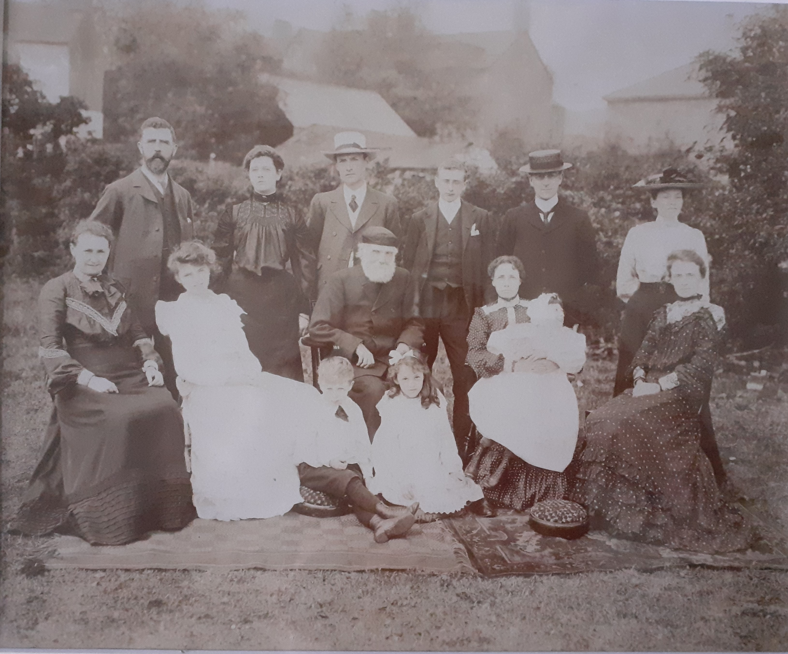
This is a group photograph of John Thomas’ Family.
Back row, L to R: Mr Watkins; Mrs Thomas; Dr Thomas; ?; ?; Miss Judd.
Seated. L to R: Mrs Watkins (nee Thomas); Susan Watkins (later Rowbottom);
Mr John Thomas; Mrs Doubleday (nee Thomas holding baby Gladys); Miss Susan Thomas.
Front row: Noel Watkins; Francis Doubleday (later Governess, Brynmawr Infant School)

Sources, if not stated in the article:
Miss Doubleday’s memories, kindly remembered by Merryl Caleb.
Brynmawr Town Council for the use of the photograph of John Thomas.
Brynmawr Museum for John Thomas’ family photograph.
The following newspapers:
27th August 1915 Abergavenny Chronicle
18th September 1909. The Cardiff Times
17th June 1909 Evening Express
15th September 1909 Evening Express
The Brecon Radnor Express Carmarthen and Swansea Valley Gazette and Brynmawr District Advertiser 27th December 1917
Abergavenny Chronicle. 17th September 1909
The Brecon Radnor Express Carmarthen and Swansea Valley Gazette and Brynmawr District Advertiser 3rd June 1915
Abergavenny Chronicle 25th June 1909
The Brecon Radnor Express Carmarthen and Swansea Valley Gazette and Brynmawr District Advertiser 26th August 1915
18th September 1909. The Cardiff Times

©Eifion Lloyd Davies. October 2020.

